**Method**

*The Click-and-Mortar Strategy*

This method is also known as the Bricks-and-clicks business strategy. In this strategy there is both a physical location as well as a virtual location. A portion of the movie production industries revenue is composed by licensing their product, therefore these products need to be sold either in a physical store location or through online sales. Disney for example, is one of the 10 largest movie production companies which has both a physical location such as Disneyland or Disney stores and sells directly to the customer through their online website which offers products at a discounted price. Having both a physical store and a virtual location can be beneficial to the company since it can increase revenue, but it can also bring complications to the company if their website seems to have security issue, its unappealing or if the website is difficult to use.

*Reintermediation*

Since the motion picture production sales are comprised of theaters box office sales, digital downloads and DVD sales, intermediaries are needed to sell and promote the industries products. The intermediary typically uses the click-and-mortar strategy where there is a physical location, or a virtual location were the products could be bought. For instance, in a movie theater individual can purchase a movie ticket directly in their physical location or they can skip the line and preorder their tickets through their online website. Middle men are essential in the sales for the film industry since many, unlike Disney, don’t have a physical location were customers can purchase their products directly through the company. The company therefore rely heavily on retail stores or virtual stores to sell their products which include as DVD sales, Digital downloads or products they’ve licensed.

*Long tail*

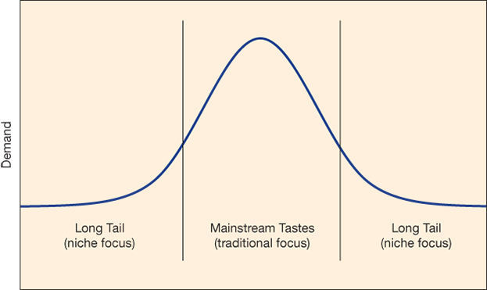

The long tail concept refers to the company’s focus in the niche markets instead of focusing on purely selling their products to a mainstream audience. Warner Bros. and Netflix’s both cater to different audiences. For instance, Warner Bros. is a large mainstream production company that caters to a large mainstream audience. Since Warner Bros. movie production can bring in a large audience their films are therefore previewed in a movie theater. Warner’s target market is geographically everyone who has access to a movie theater. In the other hand Netflix’s films are not previewed in a movie theater since they might not bring in a large audience creating a loss in any attempt in doing so therefore, Netflix focuses in producing its product to a niche market since they only target individuals who have access to their streaming online account and not to everyone geographically.

*Structural Firmness*

In order for the film industry to create a website that enhances the customers experience, the first necessity that needs to be met is the structural firmness of the website. This means making sure that the website is functioning correctly, and the security of the page is secure. If a website looks like it is not secure chances are the customer may feel uncomfortable with providing their sensitive information resulting in the customer no finalizing a payment. The website needs to be functioning correctly and properly for the customer to want to stay in the page and not turn to another competitor’s website. This means making sure that the web server reloads fast since many customers are impatient, reduce the amount of bad links in the page, and if an error occurs providing messages that are easy to analysis is important. For instance, if a customer is trying to become a member of Netflix and feels like the website is lagging, chances are that this customer has the impression that the service Netflix provides will be the same and choose not to obtain their service.

*Functional Convenience*

Functional convenience is another necessity that needs to be successfully created to enhance customers experience. If a website is difficult to navigate through, chances are the customer will not use the website. The page needs to be easy to navigate threw and give the customer the most convenience possible. For instance, Netflix website page is easy to use. Once there is an account the passcode is auto saved making it convenient for the customer, another convenience Netflix’s offers it that it saves the progress of a movie if the customer decides to watch it later, Netflix also saves the most recent films and the films are categorized based on genre1

*Representational Delight*

Finally, the last thing needed to enhance customer experience is representational delight. This means that the page needs to be inviting through the customers eyes. This is essential since this will determine whether the customer says or leaves the site. Disney website for example has their page joyful, with colors and picture making it delightful to the customer

*Social Media Marketing*

Social media marketing has been an easy way for the movie production to promote their films with low to no cost. Disney for instance uses Facebook to promote their films by having a page called Disney movie reward where members can sign up and get rewards when purchasing movie tickets. With 2.5M followers to this page, it is easy for Disney to promote their production film onto this site by post upcoming movie clips as well as promote older movies from the past. Warner Bros. is another example of the popularity of using social media as a form of Marketing. Warner’s Facebook page currently has 3.5M followers which thy post upcoming film clips. When you enter their page the first thing you see is them promoting the film Aquaman, then there is a tab that directs you to a shop now were you can purchase the film digitally or in Blu-ray or DVD. Using social media is an advantage that allows the film industry to target their specific target market more effectively and efficiently with hardly any effort. 2

*Cryptocurrencies*

A more famous type of cryptocurrencies now and days is bitcoin. Since the use of credit card have become expensive, one option the movie production industry can turn to is the usage of bitcoin for large cost payments. This can be useful since cost from the process fee that debit card and credit card usually charge will be eliminated, which will rest in more revenue for the industry. Another thing to consider, since cryptocurrencies are starting to become more popular is figuring a a system in which customers are also allowed to make purchases using cryptocurrencies. One way to encourage customers to use this type of currency is by giving them discounts on product if payment is done via cryptocurrencies, this could be done since the cost the company would have normally incurred with the process fee would be eliminated.

**Need method # and to add the sites and include Abstract**

Abstract for chapter 4 By looking into the importance of a using virtual site we concluded that industry’s need to have an appealing website that is functioning properly and is seacure to use.

1. Netflix.<https://www.netflix.com/>. Accessed March 20
2. Facebook.<https://www.facebook.com/Disney/> Accessed March 21